C:\Documents and Settings\user\Local Settings\Temporary Internet Files\Content.IE5\D8IV0ULB\MPj04330680000[1].jpg

**North East Florida Pool Service**

August 2016

Chlorine Times

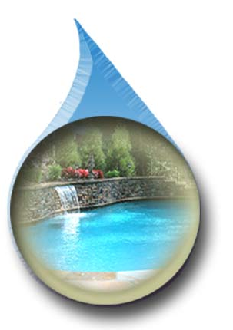

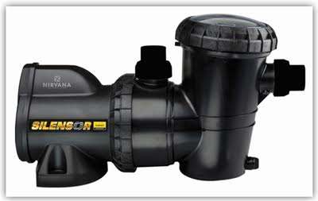

C:\Documents and Settings\user\Local Settings\Temporary Internet Files\Content.IE5\D8IV0ULB\MCj04107810000[1].wmf

Standard motor only replacements available starting at $330

***In this issue:***

* **Silensor Pump**
* **Whats included in cleaning plans**
* **Refer friends, family and neighbors for FREE service**

***General Summer Pool Care:***

* Brush pool walls twice a week
* Filter 10-12 hours daily
* Keep pool and skimmers free of debris
* D.E. systems need serviced once a year
* Sand change every 3-5 years
* New cartridges every 1-2 years

Nirvana Silensor Pump is a complete plastic housing pump, which is perfect for our salt air here in North East Florida. It means no rusted out motors. The Silensor Pump is a water cooled pump and produces heat of 2500-3100 btu/hour. This will help extend the swim season. This pump is also 52% more energy efficient than a standard replacement pump. NEFPS is the warranty Company for Nirvana pumps and heaters.

**What Are The Task Included In Our Cleaning Plans?**

Partial Service Full Service

Testing Service Service

Chemicals Service Service

Salt Cells Service Service

Brushing Service Service

DE/Sand Backwash Service Service

Skimmers Service Service

Timer Management (filtration) Service Service

Pump Pot Service Service

Vacuum Owner Service

Surface Netting Owner Service

Auto Vacuum Basket/Bag Owner Service

Water Level Owner Owner

All Tasks on Non Service Days Owner Owner

Nirvana Silensor

Pumps Installed:

1.5HP-$825 +Tax

1.0HP-$810 +Tax

3 Year Warranty!

Only 55dBA of noise.