H

904-636-0903

www.NEFPools.com

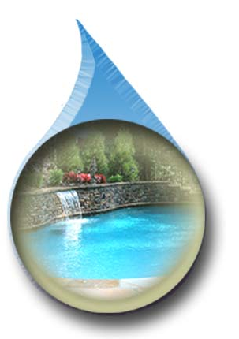

Chlorine Times

**North East Florida Pool Service.**

April 2018





***In this issue:***

***Pool Responsibilities***

***Cleaning Maintenance***

***Repair Services***

***Filter Time and Maintenance***

***Reminder: Please make sure that all pets are contained while our Service Technician is in your yard.***

**MARCH 26 THROUGH APRIL 6, 2018**

**EIGHTH ANNUAL GREEN PREVENTION WEEKS**

It is time for our EIGHTH ANNUAL Green Prevention Weeks initiative. This is a spring cleanup by customers who participate in our Water Management service programs. We do this spring cleaning for our Full Service customers as part of our weekly service at no additional cost to them. The Green Prevention goal is to establish a timeframe to coordinate super chlorination with your cleaning chores. Our time coordinated chemical initiative will combine to eradicate seasonal algae accumulation. You must brush the algae off the walls, floor and steps of your pool thereby suspending the algae in the super chlorinated water. Even if you can’t see it, algae have been building up in the pool all winter. Warm weather activates the growth of this algae; often times turning a pool green overnight. Chemicals perform best when they access all sides of algae cells and have an abundance of filtration support. ***Green Prevention Weeks are scheduled for March 26 through April 6, 2018.***

Here is what each customer participating in our Water Management service program must do ***during*** Green Prevention Weeks. Within twenty-four hours after our initial chlorination treatment the following steps should occur every 2-3 days until clear blue water is achieved:

|  |  |  |
| --- | --- | --- |
| |  |  | | --- | --- | | * Clean skimmer and pump baskets * Clean filters * Clean auto vacuum screen and remove the   vacuum from the pool   * Remove debris from pool deck area * Clean scum, oil, mineral deposits, etc. from   tile   * Skim floating debris from water surface | * Net heavy debris from bottom of pool * Vacuum bottom of pool: to waste if necessary * Vigorously brush walls, floor and steps * Return auto vacuum to pool and activate * Run filtration in 24-48 hour cycles * Repeat process until clear blue water is achieved | |

Now is the time to schedule any repairs before the swim season starts. Call our office to get your pool system operating properly before the warm weather rolls in.

Please make sure all system timers are set to the proper filtration requirements for your pool. Cartridge and DE systems should be running 8-10 hours and sand systems should be running 10-12 hours a day. With heavy pollen falling, filtration times may need to increase and when PSI on your filter increases by 10, filters need to be cleaned or backwashed.