H

904-636-0903

www.NEFPools.com



Chlorine Times

**North East Florida Pool Service**

June 2016



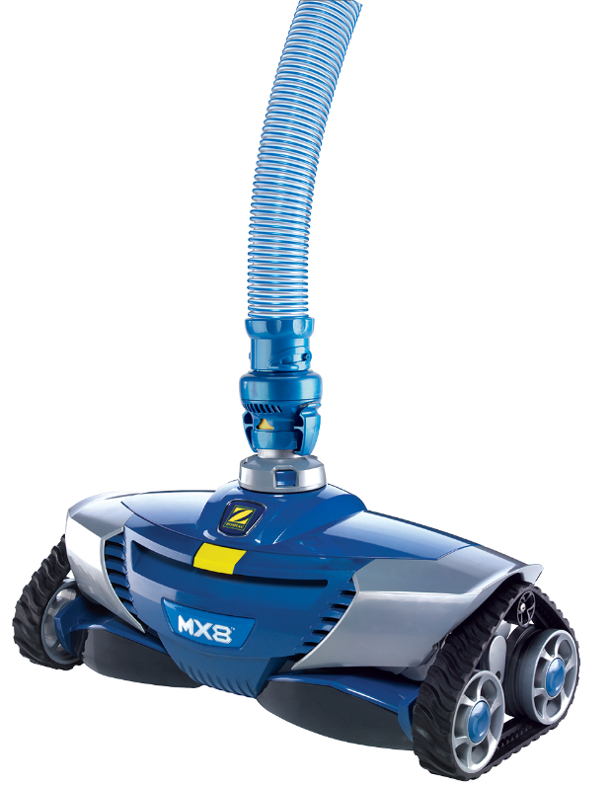C:\Documents and Settings\user\Local Settings\Temporary Internet Files\Content.IE5\D8IV0ULB\MCj04355740000[1].wmf

Ultra-Efficient Suction Pool Cleaning Robot

**Now Included!**

[[](http://www.zodiacpoolsystems.com/sitecore/content/content-database/products/zodiac-accessories/zodiac-mx-flow-regulator)  
[Zodiac MX Flow Regulator](http://www.zodiacpoolsystems.com/sitecore/content/content-database/products/zodiac-accessories/zodiac-mx-flow-regulator)](http://www.zodiacpoolsystems.com/sitecore/content/content-database/products/zodiac-accessories/zodiac-mx-flow-regulator)

The Zodiac MX8 is ready to battle your pool's toughest dirt and debris. The dual cyclonic suction enables the MX8 to move faster and deliver unsurpassed vacuum power, while requiring 30% less flow. Its ultra efficient design requires less flow than any cleaner in its class for maximum energy savings. Best choice for solar, 2-speed, and variable-speed pumps.

It has a wider cleaning path than competitor models, with a large vacuum inlet to capture larger debris. maX-drive technology promotes maximum torque and extreme maneuverability, allowing the MX8 to aggressively clean your pool walls and floors. Its twist locking hose enables quick, secure attachment to the cleaner head and the cleaner includes 39 feet of hose.

***In this issue:***

***MX8 Sale***

***Temporary Cleaning Pool Plan Upgrades Available***

***Remember, Referrals Earn Free Month Of Service!!!***

***\*\*Over the next couple weeks we will be undergoing route optimization. Please bear with us during this process.\*\****

Zodiac MX8

$398.20 After Manufacture Rebate!

Special offer on the Zodiac MX8 suction cleaner for $523.20 with a $125.00 manufacture rebate.

***General Summer Pool Care:***

* Brush pool walls twice a week
* Filter 10-12 hours daily
* Keep pool and skimmers free of debris